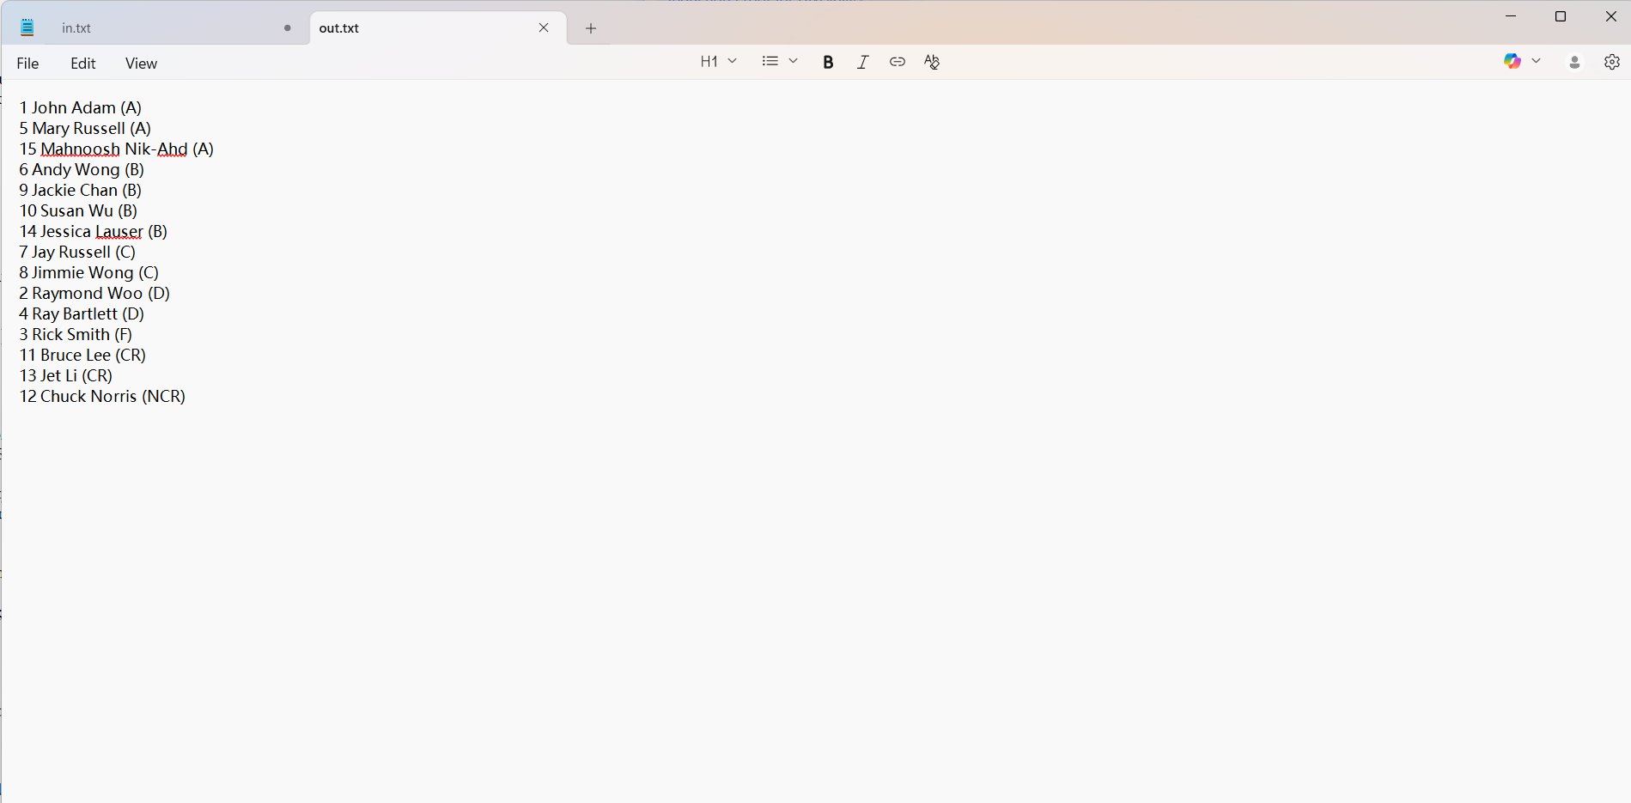
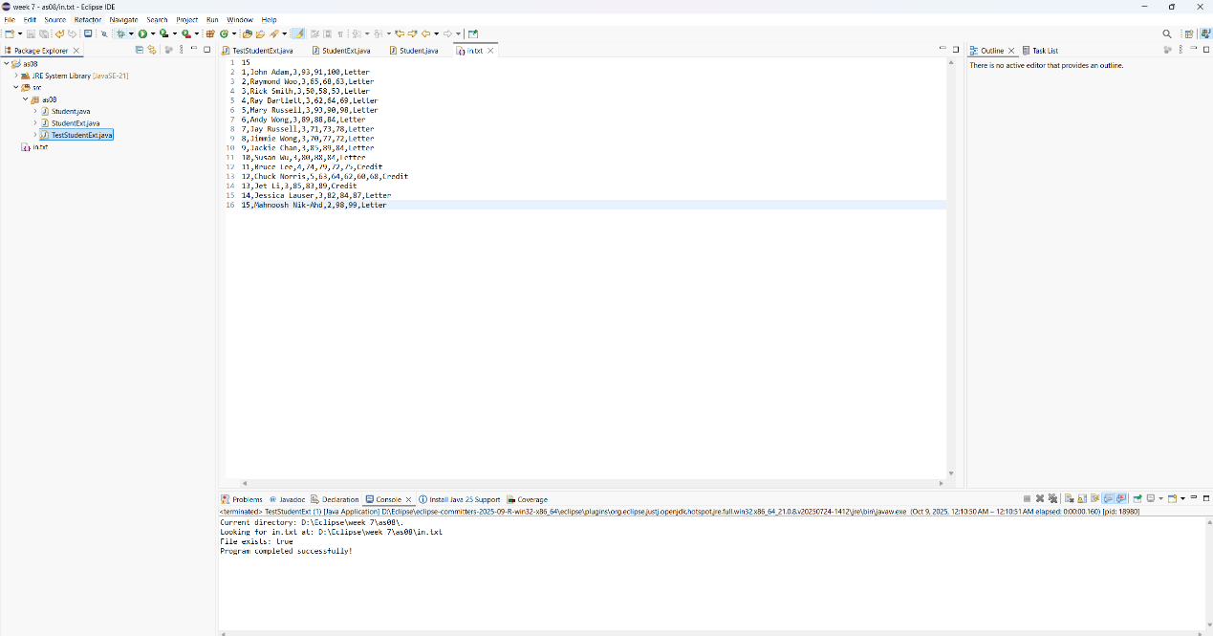
package as08;

public class Student
{
private int id;
private String name;
private double[] scores;

public Student(int id, String name, double[] scores)
{
super();
this.id = id;
this.name = name;
this.scores = scores.clone();
}

public String findGrade()
{
String grade = "";
double sum = 0;
for (int i = 0; i < scores.length; i++)
{
sum = sum + scores[i];
}
double average = sum / scores.length;

if (average >= 90.0)
grade = "A";
else if (average >= 80.0)
grade = "B";
else if (average >= 70.0)
grade = "C";
else if (average >= 60.0)
grade = "D";
else
grade = "F";

return grade;
}

public int getId()
{
return id;
}

public String getName()
{
return name;
}

public double[] getScores()
{
return scores.clone();
}
}

